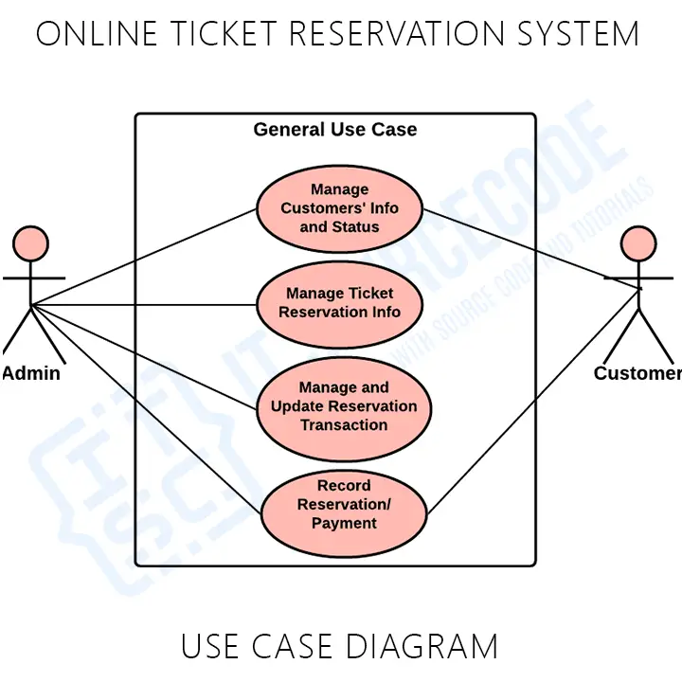

**User Stories:**

**User:**

As a user, I want to search for available tickets by entering specific details So that I can easily find the available ones.

As a user, I want to be able to purchase the ticket securely So that I can easily complete the booking process.

As a user, I want to be able to cancel my ticket So that I can get the refund once it confirms.

**Admin:**

As a admin, I want to manage the user accounts So that it can be done securely by the system.

As a admin, I want to communicate with user related to ticket confirmation So that it happens through email notifications